[](http://www.maindatainc.com/)

MAINDATA, spol.s r.o.

Senická 23

811 04 Bratislava

Slovakia

Tel: +421 905 606 027

[maindata@maindatainc.](mailto:maindata@maindata.sk)com  
www.maindatainc.com

|  |  |
| --- | --- |
| Subject: | **MAINDATA products design** |
| Access: | confidential document |

**Change History**

|  |  |  |  |
| --- | --- | --- | --- |
| **Version** | **Date** | **Author** | **Description** |
| 1.0 | 7.2.2022 | Dusan Statelov | Initial |
| 1.1. | 17.3.2022 | Dusan Statelov | Added Supermicro LED front panel |
| 1.2. | 16.4.2022 | Dusan Statelov | FPGA limits PCIe boards |
| 1.3. | 28.4.2022 | Dušan Statelov | remarks |
| 1.4. | 1.6.2022 | Dušan Statelov | Harmonic solution |
| 1.5. | 29.6.2022 | Dušan Statelov | Time sync in Harmonic, Possible FPGA & Linux processor – brainstorming. |
| 1.6. | 5.10.2022 | Dušan Statelov | SW RTOS time stamping in VM? |

|  |  |  |  |
| --- | --- | --- | --- |
|  |  |  |  |

**A|Scope of document:**

Product design for DVB SIS adapters

1. **Control stream generator**
2. **Daughter stream adapter**

Analyze proper product design for DVB SIS, design cost-efficient, maintainable, modular and reliable solution

Existing PC based server running Linux also in kernel

Figure 1 – Adapter Prototype TRL6

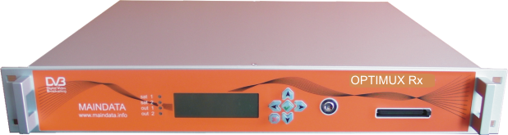

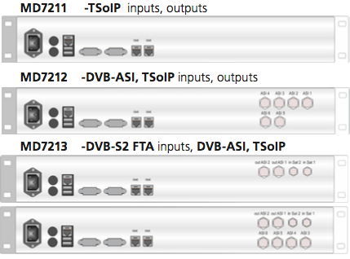Competition design:

Back panel view

1. **Enensys:**

Front

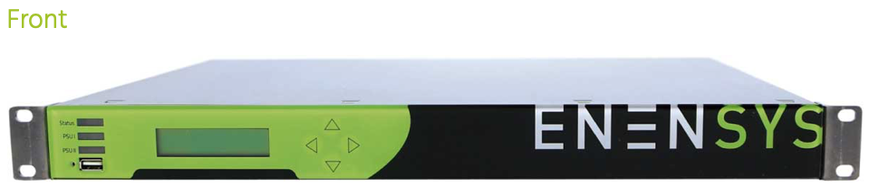

Back

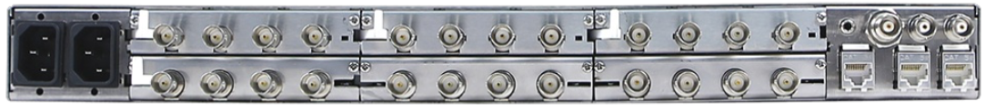

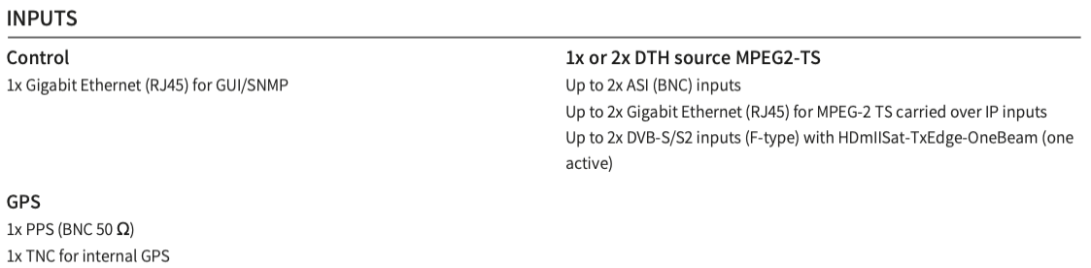

1. **Nevion:**

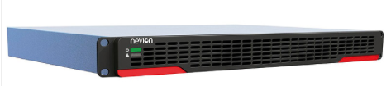

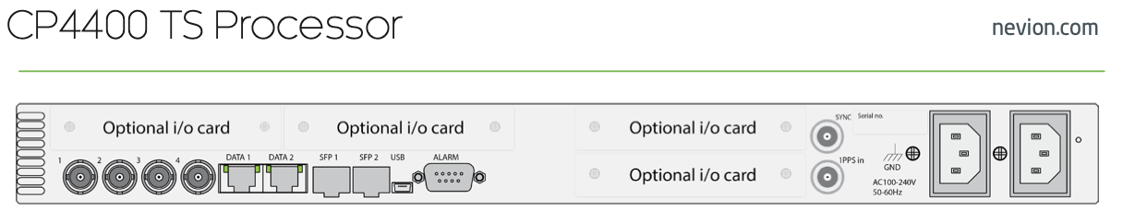

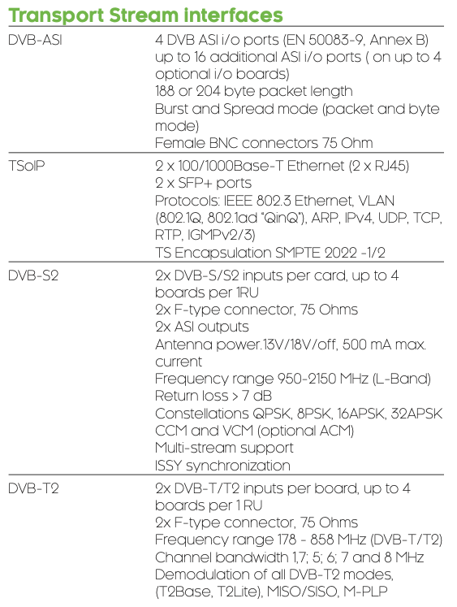

1. **Harmonic:**

Based on discussion with Harmonic reseller, Harmonic really shifted almost all or all products to SW implementation, including multiplexer, encoders, statistical multiplex etc.

It is typically installed at HP servers using modified Linux…

SW based remultiplexers are commercially deployed, used, working with STB.

Last question remains whether fully SW implementation is used also for DVB-SIS Daughter stream adapter and/or DVB-T2 GW. To be done.

According to Dektec Harmonic integrated their PCIe boards, so it seems identical to MAINDATA “old” product architecture.

Both ends of Harmonic’s DVB-SIS (ProstramX and XOS) are built in Linux and synchronization should be achieved by

a) PTP <https://en.wikipedia.org/wiki/Precision_Time_Protocol>

b) PPS/GPS adapter <https://en.wikipedia.org/wiki/Pulse-per-second_signal>

which is connected to server serial port

Harmonic solutions are installed at HP servers or virtual machines.

Generaly it runs on Linux with above described synchronization

1. **HW versus SW solution**

Is HW solution necessary or SW solution (Linux) is enough?

* 1. **In case HW solution is needed**

To what extent / for which functionalities, is HW mandatory?

* + 1. **Timing at last stage? (Latency, jitter anything else?)**
    2. **Back panel space – full of Input output connectors, without half of mother board** being occupied by motherboard connectors?
    3. **Reliability?**
    4. **Fast boot?**
    5. **Anything else?**
    6. **Redundant power?**
    7. **High Density?**
    8. **Front panel?**
  1. **In case of SW only solution using available Servers:**

Is it enough to compose bitwise precise bitstream with “unprecise or dummy” timestamps which are then precisely restamped by Modulators?

1. **Time reference**

MAINDATA products are Linux based on PC motherboard with unprecise clock.

Is that OK?

Do we need e.g. GPS PCIe board to make timing more precise?

1. **High density**

Could we use blade servers to achieve high density with specific boards e.g. for IO (e.g. DVB ASI input outputs, timestamping)

How blades are connected are PCIe boards supported (easy use of DVB-ASI boards)

1. **Inputs – outputs**

Do we need DVB-ASI or GbE is enough?

In my opinion DVB

1. **Front panel or IPMI?**

We use Front LCD panel with 6 buttons (Crystal Fontz) to allow initial IP configuration and also for basic monitoring.

It is questionable whether IPMI is not enough, as most of configuration and monitoring can be done via WEB and or SNMP

1. **Potential Blade server design?**

DVB ASI board

GNSS board

Blade PC   
with GbE

Linux

Dual Power

Satellite input module

This approach is not easilly supported by Blade Servers, sharing one satellite input board by various blades is one of most expensive architectures.

1. **Ready Supermicro server with front LCD panel**

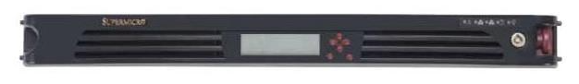

<https://www.supermicro.com/products/system/1U/1019/SYS-1019S-WR.cfm>

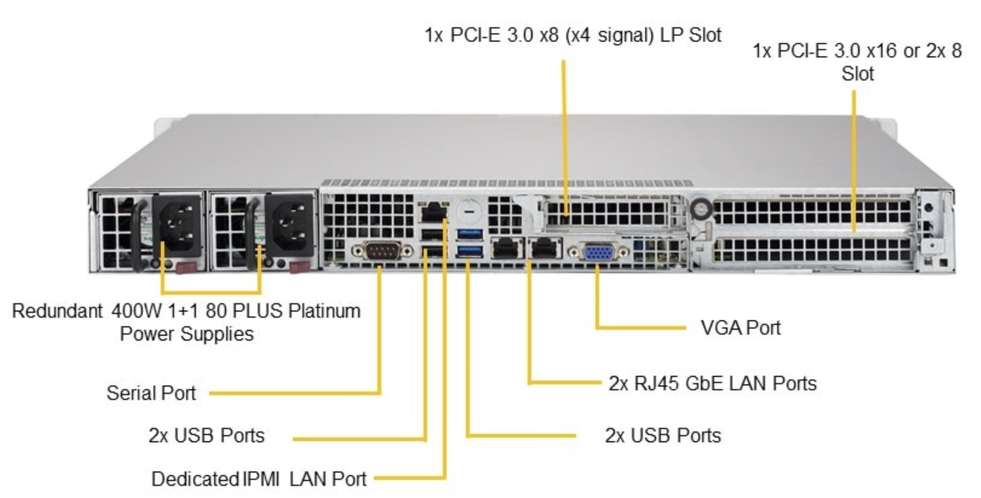

1. **Add-on module to existing third party HW eg AppearTV, Wisi group, Sumavision**
2. **Own FPGA e.g. Xylinx/Altera with central processor (linux)**

This architecture looks like is deployed by heavy professionals like Appear TV, Enensys, Nevion etc.

Advantages:

It provides much more connectors at rear panel

No need for intense SW upgrades due to kernel evolution

Low cost for high quantities (not our case)

More reliable (eliminating connectors, cables etc)

Low energy consumption

Higher security

Higher processing speed?

More credible for Telecom customers

Disadvantage:

Less modular

Less flexible - inability to add available PCIe interface board, e.g. satellite receiver directly into box.

More expensive initial development costs

**<https://www.xilinx.com/products/silicon-devices/soc/zynq-7000.html>**

**Possible alternatives of FPGA board with Linux module:**

FPGA with Processor +

IO: Satellite receiver, DVB-ASI, GbE, serial port, GPS receiver

Linux   
Processor

1

1st alternative integrated Linux processor on FPGA board. Normal Linux code after cross-compiling should work.

FPGA with Processor +

IO: Satellite receiver, DVB-ASI, GbE, serial port, GPS receiver

Server board

e.g. Supermicro

e.g. GbE

for TSoIP

2

2nd alternative – having 2 independent boards: FPGA and Server motherboard connected via Ethernet. Unified configuration should be thought out to not force user to configure separately each one.

FPGA with Processor +

IO: Satellite receiver, DVB-ASI, GbE, serial port, GPS receiver

Server board

e.g. Supermicro

e.g. PCIe

with drivers

3

3rd alternative, FPGA acting as PCIe (daughter board). This would likely lead to developing many drivers for all devices in FPGA??

1. **QUESTION: Can we perform real-time precise time stamping by SW solution?**

There are some stream processing in digital TV and generally in telecomm requiring precise time-stamping, e.g. PCR (Program clock reference) and e.g. arrival packets times stamping with GPS Epoch time in DVB SIS (Single Illumination satellite).

“Normally” this is done by FPGA real time processing, however development of FPGA takes much more time.

Hence MAINDATA architecture is Linux based with extension PCIe boards for e.g. DVB-ASI interfacing, GPS receiver, satellite receiver, or modulator.

It is needed to find out how we could implement precise real-time time stamping processes without using FPGA.

Interestingly enough one of the most renowned Digital TV suppliers Harmonic turned to fully SW based solutions, even for products where FPGA would be expected. They are said to use PPTP - precise time protocol and serial ports.

So it is challenge to find out how is it possible to support precise real time processing in SW.

There are Real time Operating systems (e.g. QNX and RTOS).

Would it be possible to run RTOS e.g. in nested Virtual machine along with Linux?

It is system architecture question with potential to impact design of several MAINDATA products.

Any comment, ideas are welcome.